# Multi-Model AI Agent for Automated Health Diagnostics

**Author:** Chepuri Rishivardhan

**Organization:** Infosys Springboard

**Project Type:** virtual internship

**Date:** January 2026

**Github link:** [rishivardhan99/Multi-Model-AI-Agent-for-Automated-Health-Diagnostics-](https://github.com/rishivardhan99/Multi-Model-AI-Agent-for-Automated-Health-Diagnostics-)

## Abstract

Multi-Model AI Agent for Automated Health Diagnostics is a artificial intelligence system designed to automate the interpretation of clinical blood reports with a specific focus on safety, deterministic accuracy, and explainability. Addressing the limitations of "black-box" diagnostic tools, the system processes heterogeneous medical data—ranging from scanned PDF reports to structured JSON payloads—through a rigorously layered pipeline. This pipeline orchestrates data extraction, clinical normalization, deterministic reasoning, and controlled narrative synthesis using Large Language Models (LLMs). Unlike monolithic deep learning systems that risk hallucination, Multi-Model AI Agent for Automated Health Diagnostics enforces a strict architectural separation between factual, deterministic computation and natural language generation. The system utilizes an Extractor module for text extraction, a Normalization module (Model-1) for standardization against clinical reference ranges, and a Reasoning module (Model-2) for transparent pattern detection. A constrained LLM (Model-3) serves solely as a narrative engine, synthesising validated insights into human-readable summaries. This project demonstrates how responsible AI principles—specifically modularity, guardrails, and auditability—can be applied to healthcare diagnostics to create a robust decision-support system that augments rather than replaces human clinical judgment.

## Table of Contents

1. Introduction & Motivation
2. System Overview
3. Extractor Module
4. Model-1: Clinical Parameter Normalization
5. Model-2: Pattern, Risk & Causal Reasoning
6. Model-3: LLM Narrative Synthesis
7. Chatbot Module
8. LLMEVALS: Evaluation & Validation
9. Integration & Orchestration
10. Safety, Guardrails & Compliance
11. Deployment & Dockerization
12. Sample Outputs & Audit Artifacts
13. Conclusion
    * Appendix A: File Manifest
    * Appendix B: Environment Variables
    * References

## List of Figures

* Figure 1: Layered System Architecture
* Figure 2: Model-1 Parameter Extraction and Normalization Flow
* Figure 3 Model-2 Pattern & Knowledge-Graph Reasoning Flow
* Figure 4: Model-3 Prompt→LLM→Validation→Redaction→Fallback Flow
* Figure 5: Chatbot RAG & Fallback Flow
* Figure 6: LLMEVALS Pairwise & Merge Evaluation Flow
* Figure 7: End-to-End System Integration Flow
* Figure 8: Example Model-3 .txt Output Sample

## 1. Introduction & Motivation

Clinical blood tests represent a fundamental diagnostic utility in modern healthcare, providing quantitative data critical for disease detection, longitudinal monitoring, and therapeutic management. However, the interpretation of these reports is a cognitively demanding task that requires the synthesis of high-dimensional parameter spaces into a coherent clinical picture. In resource-constrained environments—such as rural healthcare settings, mass screenings, or direct-to-consumer testing—timely and expert interpretation is frequently unavailable. This gap often leads to delays in treatment or the misinterpretation of critical biomarkers, particularly when subtle cross-parameter relationships are overlooked due to clinician fatigue or cognitive overload.

The current landscape of automated diagnostic tools presents a functional dichotomy. On one hand, traditional Laboratory Information Systems (LIS) rely on simple linear flagging (e.g., "High"/"Low"), failing to capture multivariate relationships or derived clinical risks. On the other hand, modern Deep Learning (DL) models offer high predictive accuracy but suffer from the "black-box" problem, lacking the transparency required for clinical trust. Furthermore, Generative AI and Large Language Models (LLMs), while linguistically fluent, are prone to stochastic hallucinations—generating plausible but factually incorrect medical inferences.

Multi-Model AI Agent for Automated Health Diagnostics addresses this interpretative gap by introducing an AI-assisted diagnostic support system prioritized for explainability, safety, and modularity. The project is motivated by the critical need for transparent medical AI systems that assist clinicians by highlighting abnormalities and explaining the underlying reasoning, rather than attempting to replace human judgment with opaque predictions. To achieve this, Multi-Model AI Agent for Automated Health Diagnostics implements a hybrid architecture that strictly confines the generative component to a synthesis role, while all diagnostic logic is handled by transparent, verifiable algorithms. This approach shifts the paradigm from "AI as an oracle" to "AI as a verifiable scribe."

## 2. System Overview

The architecture of Multi-Model AI Agent for Automated Health Diagnostics is centered on modular independence, strict data contracts, and a layered processing philosophy. The system functions as a linear pipeline of increasing abstraction, where raw unstructured data is progressively transformed into structured evidence and finally into human-readable narrative.

### 2.1 Architectural Layers

The system is organized into four distinct logical layers, ensuring separation of concerns:

1. **Extraction Layer (Extractor):** Converts visual or unstructured documents into machine-readable text. It acts as the "eyes" of the system, handling OCR noise and layout analysis.
2. **Normalization Layer (Model-1):** Standardizes extracted data against medical taxonomies and reference ranges. It acts as the "translator," ensuring all data speaks a common clinical language (e.g., standardizing units to mg/dL).
3. **Reasoning Layer (Model-2):** A deterministic inference engine that identifies clinical patterns and calculates risk scores based on hard-coded heuristics. It acts as the "brain," applying medical logic rules without stochasticity.
4. **Generative Layer (Model-3):** A strictly constrained LLM environment responsible for synthesizing the deterministic findings into a cohesive narrative. It acts as the "voice," articulating findings without inventing them.

### 2.2 Design Goals

The primary design goals governing this architecture are:

* **Determinism for Facts:** All clinical values, flags, and risk scores must be computed via deterministic code, ensuring 100% reproducibility.
* **LLM for Synthesis:** The LLM is used strictly for linguistic formulation, never for arithmetic or logical deduction.
* **Auditable Artifacts:** Every stage of the pipeline produces persistent artifacts (CSVs, JSONs) stored in specific directories (outputs/structured_per_report, outputs/model1_per_report, outputs/model2_outputs, outputs/model3, outputs/llmevals). This guarantees a complete chain of custody for every medical assertion.
* **Conservative Abstention:** The system is biased towards abstention. If data is insufficient or ambiguous, the system must refuse to generate a diagnosis rather than hallucinate one.

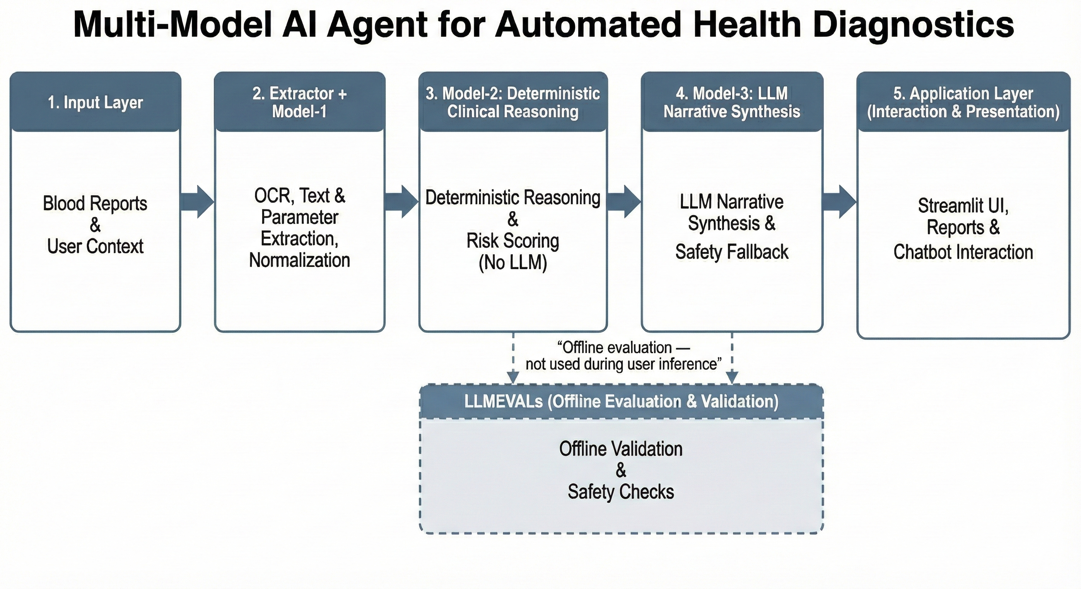**Figure: Layered System Architecture**

## 3. Extractor / Model1 Module

The Extractor module serves as the ingestion entry point for the pipeline. It is responsible for converting heterogeneous raw inputs—including PDF documents, scanned images, and structured JSON payloads—into a canonical, machine-readable CSV format. This module handles the complexities of Optical Character Recognition (OCR), noise reduction, and fuzzy parameter mapping.

### 3.1 File Descriptions

* **extractor/process_file.py:** This is the top-level orchestration script for the extraction pipeline. It manages the lifecycle of a file upload, determining whether to route the file through the OCR path or the JSON parsing path. It handles error logging, manages retries for failed OCR attempts, and ensures that the final structured CSV is written to the correct output directory.
* **extractor/step1_ingest.py:** This script performs initial file discovery and preprocessing. It identifies the MIME type of the input, splits multi-page PDFs into individual images for processing, and normalizes file names. It decides the processing strategy (e.g., "high-res OCR" vs. "fast parse") based on input characteristics.
* **extractor/step1_ocr_utils.py:** A wrapper around the OCR engine (Tesseract/PyTesseract). It handles image preprocessing operations such as deskewing, binarization, and contrast enhancement using OpenCV to maximize text recognition accuracy. It abstracts the OCR library, allowing for potential future replacement with cloud-based OCR services without refactoring the core logic.
* **extractor/param_extractor.py:** The core parsing logic resides here. This script takes raw text blocks from the OCR engine and attempts to identify clinical parameters. It utilizes fuzzy string matching to handle OCR errors (e.g., mapping "Hgb" or "Haemog1obin" to "Hemoglobin") and regular expressions to extract numeric values and units.
* **extractor/param_map.json:** A configuration file defining the dictionary of recognized parameters. It maps various textual aliases (e.g., "RBC", "Red Blood Cells", "Erythrocytes") to a single canonical ID, ensuring downstream consistency.
* **extractor/json_utils.py:** Provides utility functions for parsing inputs that are already in JSON format, bypassing the OCR step. This is critical for interoperability with other digital health systems.
* **extractor/postprocess.py:** Applies a final cleaning pass to the extracted data. It filters out low-confidence characters, corrects common OCR unit errors (e.g., reading "mg/dl" as "ng/dl" based on context), and formats the data into the strict schema required by Model-1.
* **extractor/run_batch_model1.py:** A utility for batch-processing entire directories of reports. This is essential for validation runs where hundreds of historical reports must be ingested sequentially.
* **extractor/run_model1_on_csv.py:** An adapter script that facilitates the hand-off between the Extractor and Model-1, verifying that the CSV structure meets the strict contract required by the normalization module.

### 3.2 Module Workflow (Step-by-Step)

1. **Ingestion:** The user uploads a file. step1_ingest.py analyzes the file header to determine if it is a PDF, Image, or JSON.
2. **Preprocessing:** If the file is an image/PDF, step1_ocr_utils.py applies filters to remove noise (salt-and-pepper) and correct skew.
3. **OCR Execution:** Tesseract executes on the processed image, generating a raw text blob.
4. **Parameter Extraction:** param_extractor.py scans the text blob. It iterates through keys in param_map.json, using fuzzy matching (via rapidfuzz) to find parameter names. Once a name is located, it searches the immediate vicinity for numeric patterns.
5. **Post-Processing:** postprocess.py validates the extracted numbers against a "plausibility table" (e.g., a pH of 70 is physically impossible and is discarded).
6. **Output:** A [filename].structured.csv file is generated, containing columns for Canonical Name, Raw Value, Unit, and Confidence.

### 3.3 Libraries Used — Rationale

* **pytesseract:** Chosen as the industry-standard open-source wrapper for the Tesseract OCR engine, providing robust text recognition without per-page API costs.
* **pdf2image:** Essential for converting multi-page medical PDFs into high-resolution images that Tesseract can process.
* **rapidfuzz (v3.6.1):** Selected for its high-performance string matching algorithms (Levenshtein distance), allowing the system to correctly identify parameter names even when OCR introduces typos.
* **opencv-python-headless:** Used for image pre-processing (thresholding, morphological operations) to improve OCR accuracy on low-quality scans.

### 3.4 Guardrails & Safety Measures

The Extractor implements **Numeric Plausibility Checks**. Before any value is written to the CSV, it is checked against a loose range of "physiologically possible" values. If a value is outside this range (e.g., Hemoglobin > 25 g/dL), it is flagged as an OCR_ERROR and excluded from downstream clinical reasoning to prevent cascading logic failures. Additionally, the system outputs an uncertain_fields log, allowing human auditors to review discarded data points.

## 4. Clinical Parameter Normalization

Model-1 functions as the system's "Ground Truth" generator. It is a purely deterministic module responsible for standardizing units and classifying values against medical reference ranges.

### 4.1 File Descriptions

* **model1_interpretation.py:** The core logic engine for this module. It iterates through the rows of the structured CSV. For each parameter, it looks up the specific reference range based on the patient's age and sex (if available). It performs unit conversion (e.g., converting µmol/L to mg/dL) and assigns a clinical flag (Low, Normal, High, Critical).
* **validation_and_standardization.py:** Handles the validation of input data types and the standardization of nomenclature. It ensures that "Vitamin D" and "25-OH Vitamin D" are treated as the same entity before interpretation logic is applied.

### 4.2 Module Workflow

1. **Input:** Reads the .structured.csv file.
2. **Unit Normalization:** Checks the Unit column. If it differs from the system's canonical unit, a conversion factor is applied.
3. **Reference Lookup:** Queries the reference_ranges.yaml configuration.
4. **Classification:** Compares the normalized value to the [min, max] reference interval.
5. **Output:** Generates [filename].model1_final.csv, adding columns for Normalized Value, Flag, and Interpretation Note.

### 4.3 Libraries Used — Rationale

* **python-dotenv:** Manages configuration variables, ensuring reference ranges can be swapped for different demographics without code changes.
* **numpy:** Used for vectorised numeric comparisons and handling NaN values safely during the flagging process.

### 4.4 Guardrails & Safety Measures

Model-1 enforces **Strict Unit Auditing**. If a unit cannot be recognized or converted (e.g., a typo "g/dLs"), the system refuses to guess. It flags the parameter as UNIT_ERROR and abstains from interpretation. This prevents the dangerous "unit mismatch" errors that can lead to order-of-magnitude clinical miscalculations.

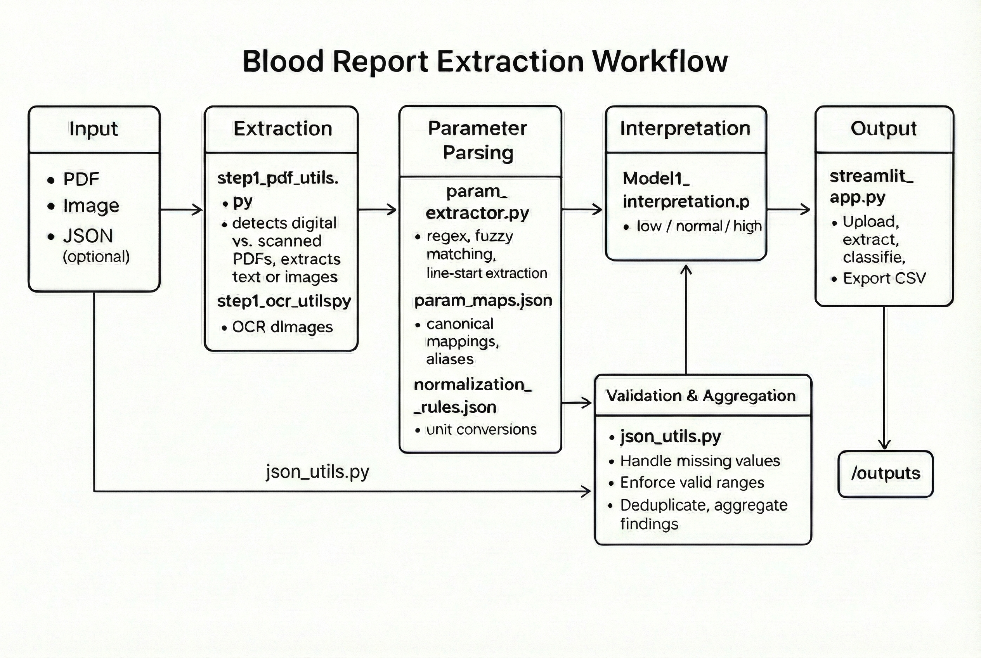

**[ Fgure: Model-1 Parameter Extraction And Normalization Flow with Streamlit as interface]**

## 5. Model-2: Pattern, Risk & Causal Reasoning

Model-2 acts as the clinical reasoning engine. It ingests the normalized data from Model-1 and uses a deterministic knowledge graph and rule engine to detect complex medical patterns.

### 5.1 File Descriptions

* **model2/model2_runner.py:** The orchestrator that loads the Model-1 CSV and sequences the execution of the pattern, risk, and causal engines.
* **pipeline/loader.py:** Converts the flat CSV data into a rich object model suitable for graph processing.
* **pattern_engine.py:** Contains a library of Boolean logic rules (e.g., IF Ferritin < 30 AND Hb < 12 THEN DETECT Iron_Deficiency_Anemia). This file is the repository of medical definitions.
* **risk_engine.py:** Calculates composite risk scores, such as the Framingham Risk Score (simplified) or Metabolic Syndrome risk, based on weighted aggregations of lipid and glucose markers.
* **knowledge_graph.py:** Models the physiological relationships between parameters (e.g., the link between Calcium and Albumin). It allows the system to traverse edges to find related abnormalities.
* **probable_causes.py:** Uses the knowledge graph to generate a ranked list of "Potential Etiologies" for detected patterns (e.g., suggesting "Hypothyroidism" as a cause for "High Cholesterol" if TSH is also elevated).
* **confidence.py:** Computes a confidence score (0.0 to 1.0) for every detected pattern based on the number of supporting data points.
* **verifier.py:** A safety module that validates the internal consistency of the deductions before serialization.
* **serializer.py:** Responsible for writing the final model2.json artifact, ensuring it adheres to the strict schema required by Model-3.
* **priors.py**, **signals.py**, **themes.py**, **quality_checks.py**: Support files defining Bayesian priors for causes, signal aggregation logic, clinical themes (e.g., "Liver Function"), and data quality assertions.

### 5.2 Module Workflow

1. **Ingestion:** loader.py creates a patient state object.
2. **Pattern Matching:** pattern_engine.py iterates through defined rulesets. Matches are recorded with a severity level.
3. **Risk Calculation:** risk_engine.py computes numerical risk indices.
4. **Causal Reasoning:** knowledge_graph.py and probable_causes.py link patterns to potential root causes.
5. **Validation:** verifier.py checks for contradictions (e.g., flagging both "Anemia" and "Polycythemia").
6. **Output:** serializer.py writes the comprehensive model2.json.

### 5.3 Libraries Used — Rationale

* **jsonschema:** Used to rigorously validate the output JSON. This ensures that Model-3 never receives malformed data.
* **tenacity:** Implements retry logic for any internal graph traversals or external queries (if configured).
* **networkx (implicit in knowledge graph logic):** Facilitates the traversal of parameter relationships to identify root causes.

### 5.4 Guardrails & Safety Measures

Model-2 implements **Evidence Completeness Scoring**. Every detected pattern is assigned a confidence score. If a critical parameter is missing (e.g., diagnosing Anemia without an MCV value), the system marks the pattern as Low Confidence or Suspected. quality_checks.py raises a critical_missing alert if high-priority signals (like Troponin) are absent in a relevant context.

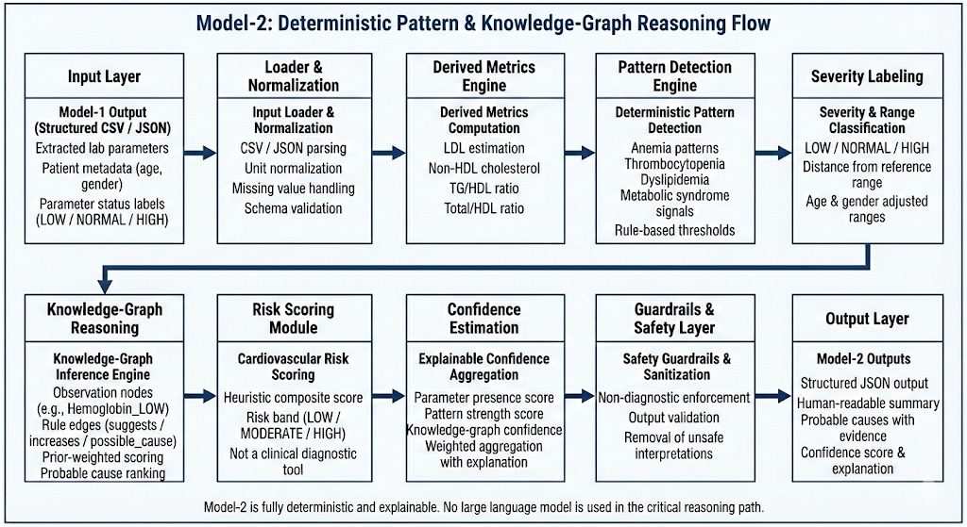

**[Figure: Model-2 Pattern & Knowledge-Graph Reasoning Flow]**

## 6. Model-3: LLM Narrative Synthesis

Model-3 is the generative interface of the system. Its sole responsibility is to translate the deterministic evidence from Model-2 into a human-readable narrative, strictly adhering to safety rules.

### 6.1 File Descriptions

* **model3/model3_runner.py:** The controller that manages the prompt construction, LLM API invocation, and response processing. It handles the fallback logic: if the primary LLM fails or is rejected by guardrails, it triggers a deterministic template fallback.
* **model3/prompts.py:** Contains the prompt templates. Crucially, it defines the "System Preamble" which includes non-negotiable rules (Rule-11, Rule-13, Rule-14) enforcing the "Use Only Provided Facts" constraint. It constructs the REPORT_VALUES block to anchor the LLM to specific numbers.
* **model3/context.py:** Sanitizes user-provided context (age, gender, lifestyle) and injects it into the prompt in a deterministic format, ensuring the LLM doesn't over-interpret subjective user inputs.
* **model3/gemini_client.py:** Handles the connection to the Google Gemini API. It manages authentication, request formatting, and exponential backoff strategies for rate limits.
* **model3/guardrails.py:** A post-processing safety filter. It scans the LLM's raw text output for forbidden phrases (e.g., "I prescribe", "Stop taking"). It enforces redaction and ensures the output matches the required JSON structure.
* **model3/schema_model3.json:** The strict JSON schema defining the expected output: summary, possible_explanations, lifestyle_guidance, when_to_consult_doctor, and notes.

### 6.2 Deep Technical Narrative

The core innovation of Model-3 is its "Constraint to Narration." The prompt is constructed by prompts.py using a technique called **Contractual Prompting**. The prompt includes a REPORT_VALUES block containing the raw numbers and a FACTS block containing Model-2's deterministic findings. The LLM is explicitly instructed via **Rule-11** ("Do not diagnose; report findings") and **Rule-13** ("Cite values for every claim").

The execution flow proceeds as follows:

1. **Prompt Assembly:** model3_runner.py compacts the Model-2 JSON to fit the context window and combines it with the prompts.py template.
2. **Inference:** gemini_client.py sends the payload to the API.
3. **Parsing:** The response is stripped of Markdown code fences.
4. **Schema Validation:** The output is parsed and validated against schema_model3.json. If validation fails, the system retries.
5. **Redaction:** guardrails.py scans the lifestyle_guidance section. If it detects prescriptive language (e.g., "Take 500mg"), it replaces the text with a safety placeholder.
6. **Deterministic Fallback:** If the LLM consistently fails or produces unsafe content, model3_runner.py abandons the generative path and constructs a rigid summary using pre-written templates based on Model-2 flags.

### 6.3 Libraries Used — Rationale

* **requests:** Used for handling the HTTP traffic to the Gemini API, preferred for its transparency over opaque SDKs.
* **jsonschema:** Critical for enforcing the structural contract of the LLM output.
* **python-dotenv:** Secures API keys, ensuring they are never hard-coded.

### 6.4 Guardrails & Safety Measures

Model-3 enforces the **"Do Not Invent" Rule**. prompts.py includes a one-shot example that demonstrates how to say "Data insufficient" rather than guessing. guardrails.py specifically protects the when_to_consult_doctor field; if the LLM suggests "Immediate ER visit" for a benign condition, the guardrail overrides this with a recommendation based on the Model-2 risk score.

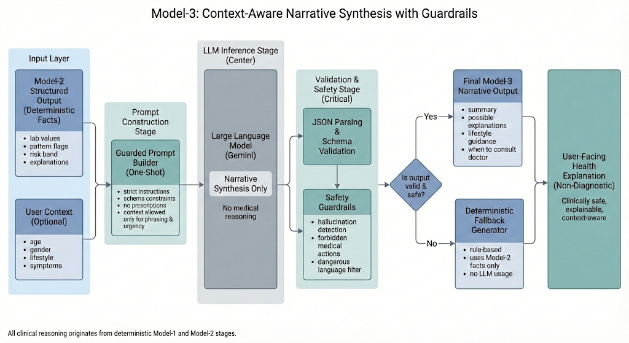

**[Figure: Model-3 Prompt→LLM→Validation→Redaction→Fallback Flow]**

## 7. Chatbot Module

The Chatbot module enables interactive, "human-in-the-loop" exploration of the medical report. It uses Retrieval-Augmented Generation (RAG) to answer questions based *only* on the processed artifacts, strictly preventing access to general internet medical knowledge.

### 7.1 File Descriptions

* **chatbot/chatbot_runner.py:** The main server loop for the chatbot backend. It maintains the session state and routing of user queries.
* **chatbot/retrieval/retriever.py:** Implements the RAG logic. It uses vector embeddings to search the model2.json and model3.txt artifacts for relevant context chunks matching the user's query.
* **chatbot/safety_guard.py:** A pre-inference check that refuses dangerous queries (e.g., "How do I overdose?").
* **chatbot/deterministic_summary.py:** Generates a fallback answer if the RAG retrieval score is too low.
* **chatbot/context_builder.py:** Assembles the prompt by concatenating the retrieved chunks with the user's query history.
* **chatbot/llm/gemini_llm.py & grok_llm.py:** Abstractions for the LLM providers, allowing the chatbot to switch backends.
* **chatbot/ingestion/*:** Scripts for chunking the report artifacts and building the vector index.

### 7.2 Workflow

1. **Context Building:** The system prefers the model3_txt (narrative) but falls back to model2_json (evidence) if the narrative is incomplete.
2. **RAG:** retriever.py fetches the top 3 relevant chunks.
3. **Safety Check:** safety_guard.py acts on both input and output.
4. **Response:** The LLM generates a response citing the specific chunks used.

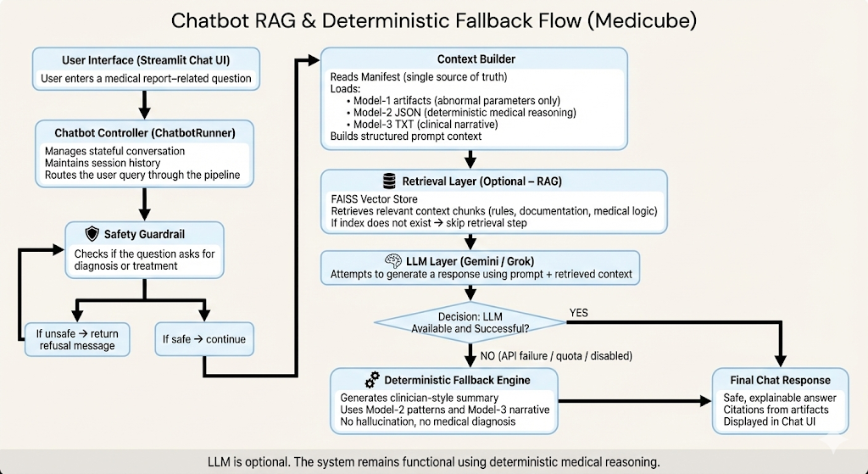

**[ Figure: Chatbot RAG & Fallback Flow]**

## 8. LLMEVALS: Evaluation & Validation

LLMEVALS is an offline framework designed to audit the system's performance. It utilizes an "Abstention-Aware" metric, recognizing that in medicine, "I don't know" is a safer and better answer than a hallucinated guess.

### 8.1 File Descriptions

* **llmevals/llmevals_pkg/evaluator.py:** The orchestrator for the evaluation campaign. It runs the system in pairwise (Model-2 vs Model-3) or merge modes.
* **llmevals/llmevals_pkg/validation.py:** Contains the scoring logic. It defines the penalties for hallucinations and the rewards for "Clinical Abstention."
* **llmevals/llmevals_pkg/report.py:** Compiles the final_report.json and .md summaries.
* **llmevals/llmevals_pkg/client.py:** A dedicated client for the evaluation LLM (often a different model than production, for independence).
* **llmevals/llmevals_pkg/prompt_templates.py:** Holds the "Judge" prompts used to evaluate the fidelity of the narrative against the evidence.

### 8.2 Evaluation Philosophy

The system separates **Technical Abstention** (system crash, API failure) from **Clinical Abstention** (system refusal due to ambiguity). Clinical Abstentions are counted as system_pass = True. This incentivies the model to be conservative. The framework saves a .eval.json for every file, creating a permanent audit trail of validation.

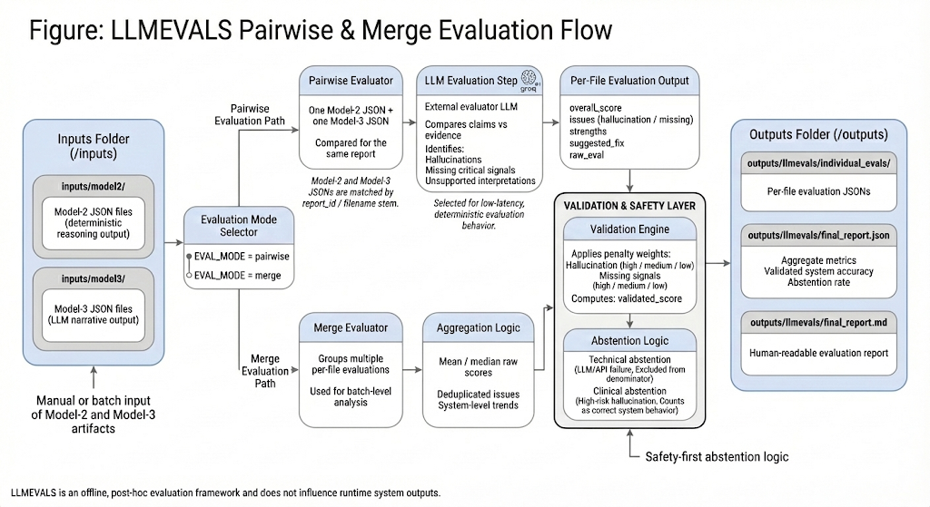

**[Figure: LLMEVALS Pairwise & Merge Evaluation Flow]**

## 9. Integration & Orchestration

The app.py script is the central nervous system of Multi-Model AI Agent for Automated Health Diagnostics, orchestrating the flow of data between the isolated modules and managing the user session via Streamlit.

### 9.1 Application Flow

1. **Entry:** User uploads a file. app.py saves it to working_inputs/.
2. **Sequence:**
   * Call extractor.run: Generates structured.csv.
   * Call run_model1: Generates model1_final.csv.
   * Call model2_runner: Generates model2.json.
   * Call model3_runner: Generates model3.json.
3. **Persistence:** All artifacts are written to disk immediately. Session state tracks the pipeline_completed flag.
4. **Display:** The UI renders the JSONs into readable widgets.

### 9.2 Data Persistence

Artifacts are persisted in a structured directory tree (outputs/model2_outputs, etc.). This is not just for debugging; it is a regulatory requirement to maintain the "Raw Data," "Derived Evidence," and "Final Report" for audit purposes.

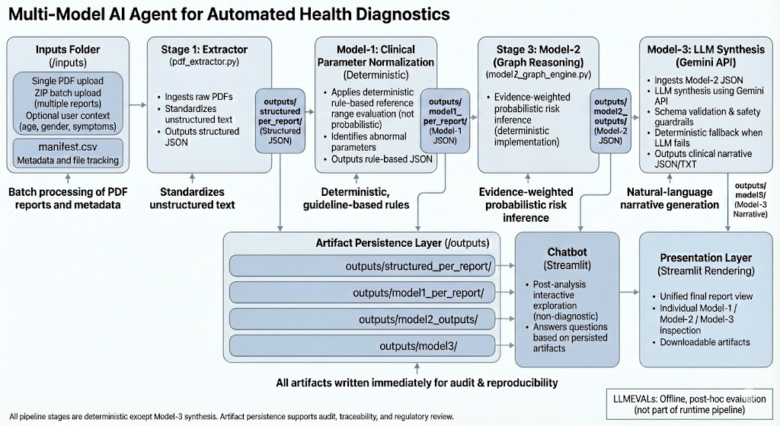

**[Figure: End-to-End System Integration Flow]**

## 10. Safety, Guardrails & Compliance

* **Extractor:** Implements numeric plausibility checks to reject OCR errors (e.g., pH 70).
* **Model-2:** Implements deterministic consistency checks. A patient cannot be both "High Risk" and "Low Risk" for the same metric.
* **Model-3:** Implements strict redaction for prescriptive language. The prompt forbids diagnosis.
* **Chatbot:** Implements refusal logic for diagnostic queries.
* **Data Protection:** .env files manage secrets. No patient data is sent to LLMs without being sanitized or part of a transient, stateless request.
* **Disclaimer:** All outputs are labeled "Assistive Only."

## 11. Deployment & Dockerization

The system is containerized to ensure reproducibility.

* **Dockerfile.ui:** Builds the main Streamlit application image, bundling all Python dependencies and Tesseract binaries.
* **model3/Dockerfile:** A lightweight image for the Model-3 runner, optimized for network I/O.
* **llmevals/Dockerfile:** A standalone image for running offline evaluations.

**Environment Variables (Appendix B)** control the runtime configuration (e.g., GEMINI_API_KEY, EVAL_MODE), allowing the system to switch between "Research" and "Production" modes without code changes.

## 12. Sample Outputs & Audit Artifacts

### 12.1 Model-3 JSON Structure

The .model3.json file contains:

* **Summary:** A high-level overview of the patient's health status.
* **Possible Explanations:** Deterministic causal links (e.g., "Low Iron -> Anemia").
* **Lifestyle Guidance:** Conservative, general advice.
* **When to Consult:** Specific triggers based on risk scores.

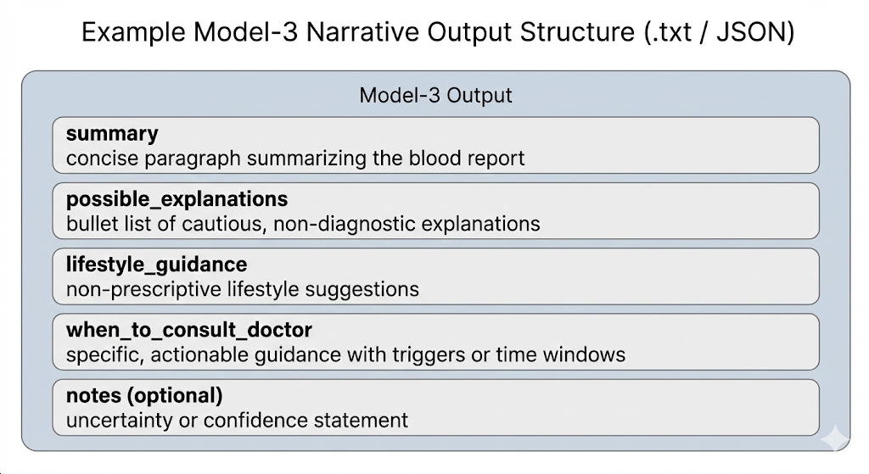

This figure illustrates the logical structure of the Model-3 narrative output.  
It presents the semantic sections enforced through schema validation, deterministic constraints, and safety guardrails, without exposing implementation-level JSON details.  
Each section supports explainable, non-diagnostic communication of Model-2 reasoning results, while full schemas and validation rules are maintained separately for auditability.

**[Figure: Example Model-3 .txt Output Sample]**

### 12.2 LLMEVALS Report

The .eval.json summarizes:

* **Hallucination Count:** 0 (Ideal).
* **Abstention Type:** None/Clinical/Technical.
* **Validated Score:** A float (0.0 - 1.0) representing safety-adjusted accuracy.

## 13. Conclusion

Multi-Model AI Agent for Automated Health Diagnostics represents a significant advancement in the architecture of clinical decision support systems. By rejecting the "black-box" paradigm in favour of a modular, multi-model pipeline, the system achieves the dual goals of high clinical utility and rigorous safety. The hard architectural separation of deterministic reasoning (Model-2) from narrative synthesis (Model-3) effectively mitigates the risk of hallucination, while the "Abstention-Aware" evaluation framework ensures that the system is rewarded for knowing its limits. This project serves as a blueprint for the responsible integration of Large Language Models into high-stakes healthcare environments.

## Appendix A: File Manifest

|  |  |  |
| --- | --- | --- |
| **Module** | **Filename** | **Role** |
| **Root** | app.py | Main Streamlit orchestrator and UI entry point. |
|  | Dockerfile.ui | Docker configuration for the main application container. |
|  | requirements.ui.txt | Python dependencies for the UI and core pipeline. |
|  | streamlit_app.py | Alternative UI entry point (if applicable). |
|  | table_utils.py | Helper functions for rendering data tables in the UI. |
|  | validation_and_standardization.py | Core logic for standardizing medical parameters. |
|  | commands.txt | Reference file for CLI commands and build instructions. |
| **Extractor** | extractor/process_file.py | Orchestrates the extraction pipeline (OCR vs JSON). |
|  | extractor/param_extractor.py | Maps raw text/regex to canonical parameter IDs. |
|  | extractor/json_utils.py | Utilities for parsing structured JSON inputs. |
|  | extractor/postprocess.py | Cleans extracted data and applies plausibility checks. |
|  | extractor/run_batch_model1.py | script for batch processing multiple reports. |
|  | extractor/run_model1_on_csv.py | Bridge script to feed extractor output to Model-1. |
|  | extractor/step1_ingest.py | Initial file handling and type detection. |
|  | extractor/step1_ocr_utils.py | Wrapper for Tesseract OCR and image preprocessing. |
|  | extractor/param_map.json | Configuration mapping aliases to canonical names. |
| **Model-1** | model1_interpretation.py | Applies reference ranges and normalizes units. |
|  | validation_and_standardization.py | (Shared) Validation logic for parameter inputs. |
| **Model-2** | model2/model2_runner.py | Orchestrates the deterministic reasoning pipeline. |
|  | model2/serializer.py | Handles JSON serialization of reasoning artifacts. |
|  | model2/verifier.py | Validates Model-2 outputs against schema. |
|  | model2/pipeline/loader.py | Loads Model-1 CSV data into internal objects. |
|  | model2/pattern_engine.py | Logic engine containing boolean pattern rules. |
|  | model2/probable_causes.py | Infers etiology based on detected patterns. |
|  | model2/knowledge_graph.py | Models relationships between parameters. |
|  | model2/risk_engine.py | Calculates numerical risk scores. |
|  | model2/confidence.py | Computes confidence scores for patterns. |
|  | model2/priors.py | Bayesian priors for causal ranking. |
|  | model2/quality_checks.py | Validates data consistency and sufficiency. |
|  | model2/signals.py | Aggregates individual parameter flags. |
|  | model2/themes.py | Groups findings into clinical themes (e.g., Liver). |
| **Model-3** | model3/model3_runner.py | Orchestrates LLM narrative generation. |
|  | model3/prompts.py | Constructs guarded prompts with system preambles. |
|  | model3/context.py | Manages user context injection. |
|  | model3/guardrails.py | Sanitizes LLM output and enforces redaction. |
|  | model3/gemini_client.py | API client for Google Gemini service. |
|  | model3/schema_model3.json | strict JSON schema for narrative output. |
| **Chatbot** | chatbot/chatbot_runner.py | Backend service for the chat interface. |
|  | chatbot/context_builder.py | Assembles RAG context for queries. |
|  | chatbot/deterministic_summary.py | Generates fallback answers without LLM. |
|  | chatbot/dev_app.py | Standalone development UI for chatbot. |
|  | chatbot/config_loader.py | Loads chatbot configuration settings. |
|  | chatbot/llm/factory.py | Factory pattern for LLM provider instantiation. |
|  | chatbot/llm/gemini_llm.py | Gemini implementation of LLM interface. |
|  | chatbot/llm/grok_llm.py | Grok implementation of LLM interface. |
|  | chatbot/retrieval/retriever.py | Implements vector search/RAG logic. |
|  | chatbot/safety_guard.py | Filters unsafe user queries. |
|  | chatbot/ui/chat_ui.py | Streamlit components for the chat window. |
|  | chatbot/ingestion/* | Scripts for indexing report artifacts. |
|  | chatbot/utils/file_utils.py | File handling utilities for chatbot. |
| **LLMEVALS** | llmevals/llmevals_pkg/client.py | LLM client for evaluation tasks. |
|  | llmevals/llmevals_pkg/evaluator.py | Main evaluation logic (pairwise/merge). |
|  | llmevals/llmevals_pkg/prompt_templates.py | Prompts for the "Judge" LLM. |
|  | llmevals/llmevals_pkg/report.py | Generates final evaluation reports. |
|  | llmevals/llmevals_pkg/run_eval.py | CLI entry point for running evaluations. |
|  | llmevals/llmevals_pkg/validation.py | Scoring and abstention logic. |

## Appendix B: Environment Variables

* **GEMINI_API_KEY**: Authentication key for Google Gemini API. (No Default)
* **GEMINI_MODEL**: Specific model version tag. (Default: gemini-1.5-flash)
* **GROQ_API_URL**: Endpoint for Grok API (if used as fallback).
* **GROQ_API_KEY**: Authentication key for Grok.
* **CLIENT_TYPE**: Selector for LLM backend (gemini, groq, mock).
* **MODEL_NAME**: Internal identifier for logging.
* **MAX_TOKENS**: Limit for generation output. (Default: 1024)
* **MAX_CHARS_PER_ITEM**: Truncation limit for inputs. (Default: 12000)
* **MERGE_BATCH_SIZE**: Batch size for evaluation merging. (Default: 5)
* **SOFT_PASS_THRESHOLD**: Score threshold for "Soft Pass". (Default: 0.7)
* **SYSTEM_PASS_THRESHOLD**: Score threshold for system validation. (Default: 0.9)
* **EVAL_MODE**: Toggle for evaluation strategy. (pairwise or merge)